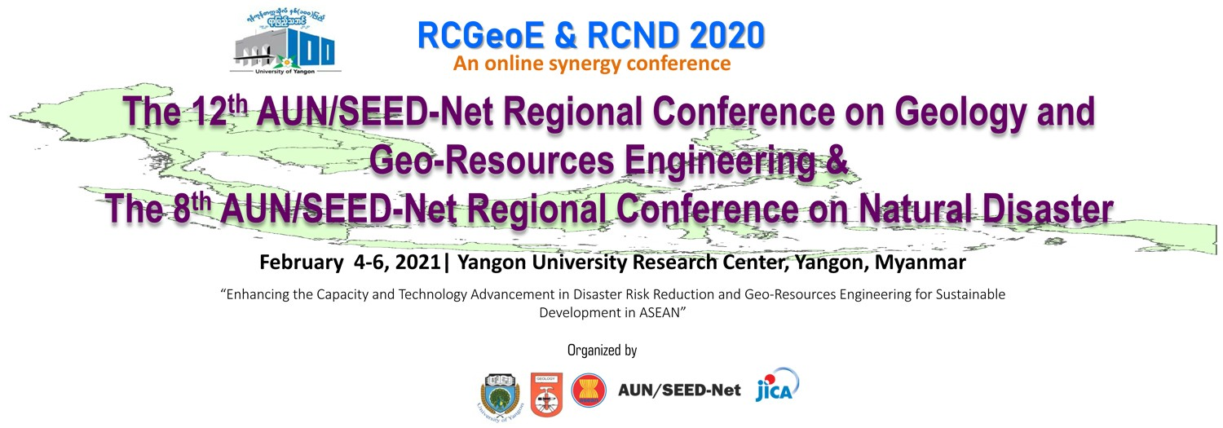

Thank you for registering to attend the RCGeoE & RCND 2020 Conference. You will need to complete a separate registration form for each individual attending.

If you have any questions about registration, please call 95-9-250074719 and 95-9-683987387.

Please send back this registration form (and bank receipt) to [uyrcgeoe@uy.edu.mm](mailto:uyrcgeoe@uy.edu.mm) and [uyrcnd@uy.edu.mm](mailto:uyrcnd@uy.edu.mm)

**Title :** Choose an item.

**Name :** Click or tap here to enter text.

**Designation/:** Click or tap here to enter text.

**Position**

**University/ :** Click or tap here to enter text.

**Ministry**

**Street Address :** Click or tap here to enter text.

Click or tap here to enter text.

**City :** Click or tap here to enter text.

**Postal Code / Zip Code :** Click or tap here to enter text.

**Country :** Click or tap here to enter text.

**E-mail :** Click or tap here to enter text.

**Phone Number :** Click or tap here to enter text.

**Please select the area of registration you would like:** Choose an item.

## Seminar Title

## Click or tap here to enter text.

**Payment**

**Kanbawza Bank : (Account no.- 16030216000585201)**

**Kpay : (09400359896)**

**Date :** Click or tap to enter a date.

**Sign :**